Knowsphere - GraphRAG - Groq-GPT-OSS-20B

Project Description:
KnowSphere is an enterprise-grade GraphRAG (Graph-Augmented Retrieval-Augmented Generation) platform built to overcome a core limitation of standard vector RAG: its inability to follow multi-hop, indirect relationships across disparate corporate assets. Built with FastAPI, a React + TypeScript + Vite frontend, a Neo4j / embedded NetworkX knowledge graph, a FAISS vector index, and Groq-hosted LLM synthesis, it lets teams navigate organizational silos, uncover cross-project dependencies, and get answers grounded in verifiable document citations.
The platform is organized around a hybrid retrieval pipeline. When a user asks a question, KnowSphere runs a dense FAISS similarity search over document chunks (embedded with the all-MiniLM-L6-v2 sentence-transformer), uses an LLM to extract and disambiguate the entities named in the question, and traverses the knowledge graph to trace structural relationships such as Team → Technology → Project. The combined context is passed to Groq's openai/gpt-oss-20b model, which returns a structured JSON answer containing findings, a graph-path explanation, cited sources, follow-up suggestions, and the IDs of the subgraph nodes to visualize.
Around this core, KnowSphere provides JWT-authenticated users, persistent chat sessions, a document-upload workflow that runs a background ingestion pipeline (.txt, .md, .docx, .pdf, .xlsx, .xls, .csv), an interactive graph explorer, analytics endpoints (projects by technology, department projects, top relationships), an activity log, and data-source management. A zero-Docker embedded mode (NetworkX + SQLite + local FAISS) runs from a single python run.py command, and if Neo4j is not detected at startup the application transparently falls back to the embedded graph engine.

Scenarios
Scenario 1: A user asks, “Which projects depend on technologies used by Team A and could be affected if that technology is discontinued?” KnowSphere traces (Team A) →[:USES]→ (Technology) →[:DEPENDS_ON]→ (Project Phoenix, Project Nova, Project Atlas), returns findings with citations such as Tech_Roadmap.docx and Project_Dependencies.xlsx, and highlights the exact subgraph in the interactive viewer.
Scenario 2: A knowledge manager uploads a new Word document. The API validates the extension, stores the file, and immediately returns a “processing” status while a background task ingests it; once complete, the document record is marked done, its extracted entities become viewable, and an entry appears in the recent-activity feed.
Scenario 3: An analyst opens the Analytics view to see projects per technology, project counts per department, and the most common relationship types, while a follow-up question in the same chat session reuses the last ten messages of history so the assistant keeps its conversational context.

Technical Architecture:
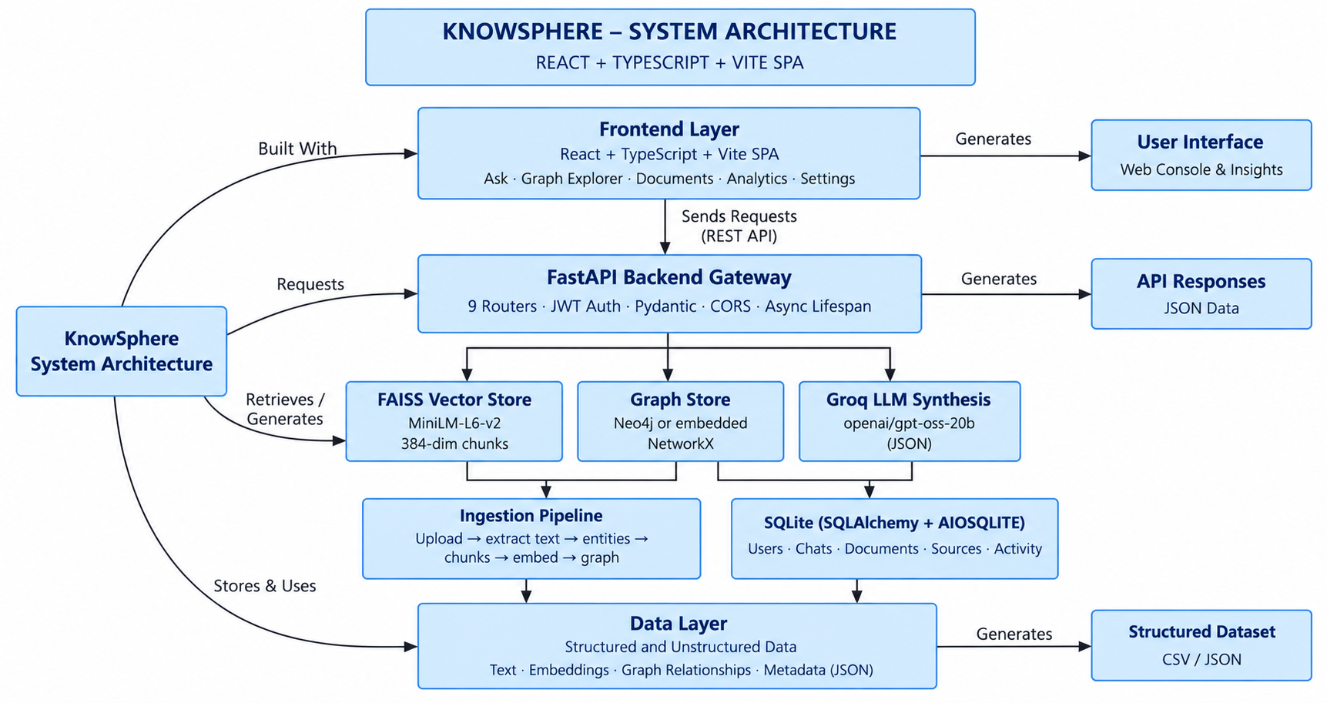

Description:
KnowSphere follows a layered architecture. The React + TypeScript SPA (Vite, Tailwind CSS, Lucide icons, React Flow graph explorer) talks to the FastAPI gateway over REST/JSON through a typed API client. The gateway registers nine routers — auth, stats, ask, chat, graph, documents, insights (with an activity sub-router), entities, and datasources — validates payloads with Pydantic, secures user routes with JWT bearer tokens, and manages start-up and shutdown through an async lifespan handler that initializes SQLite, probes for Neo4j, loads the embedded graph store, loads the FAISS index, and schedules an embedding-model warm-up in a background thread.
The /ask endpoint delegates to the GraphRAG chain, which combines FAISS dense retrieval, LLM-based entity extraction and disambiguation, and graph traversal through Cypher-style queries (against Neo4j or the embedded NetworkX store), before Groq's openai/gpt-oss-20b synthesizes a structured answer. Document uploads flow through a separate ingestion pipeline that extracts text and entities and updates the graph and vector index. Relational state — users, chat sessions and messages, document metadata, data sources, and the activity log — is stored in SQLite through SQLAlchemy's async engine.

ER Diagram :

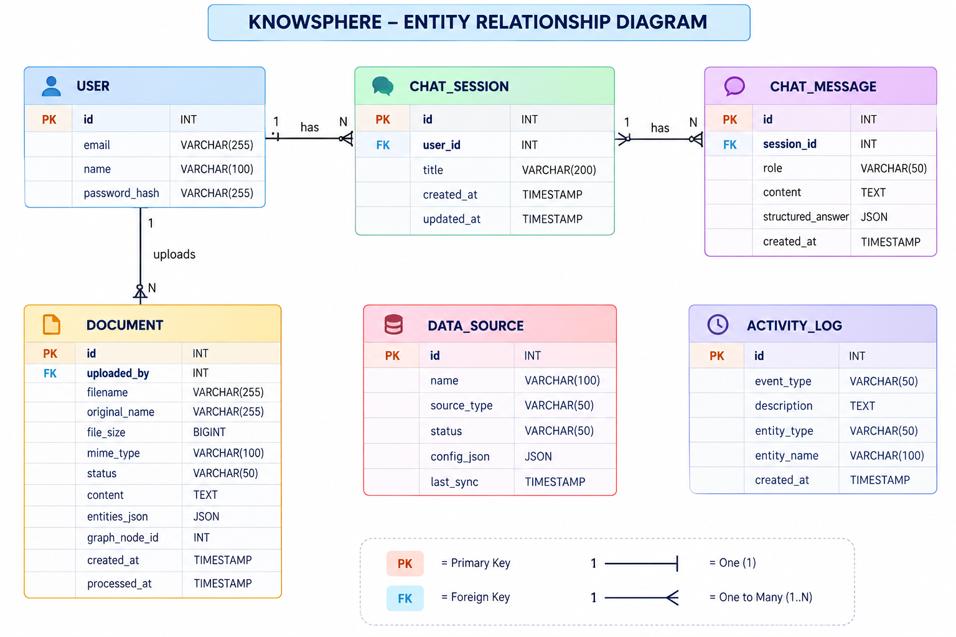

Description : The KnowSphere Entity Relationship Diagram represents the database architecture and shows how key entities are connected within the system. It includes User, Chat Session, Chat Message, Document, Data Source, and Activity Log tables. Each table defines important attributes along with primary and foreign keys. The diagram clearly illustrates one-to-many relationships between users, sessions, messages, and documents, providing a structured view of how data is stored, linked, and managed across the application

Pre-requisites:
- Python Programming Proficiency: Python Documentation
- FastAPI & Async SQLAlchemy: FastAPI Documentation
- React & TypeScript Knowledge: React Documentation
- Graph Databases (Neo4j / Cypher): Neo4j Documentation
- Vector Search with FAISS: FAISS Documentation
- Sentence Embeddings: Sentence-Transformers Documentation
- LLM API Integration (Groq): Groq API Documentation
- Version Control with Git: Git Documentation

Project Workflow:

Milestone 1: Model Selection and Architecture
- Activity 1.1: Configure environment secrets (.env) and select the LLM inference provider.
- Activity 1.2: Research and select the retrieval, embedding, and graph-storage approach for GraphRAG.
- Activity 1.3: Define the architecture of the application, detailing interactions between the frontend, backend, retrieval pipeline, and storage layers.
- Activity 1.4: Set up the development environment, installing backend and frontend dependencies.

Milestone 2: Core Functionalities Development
- Activity 2.1: Develop the core functionalities: hybrid GraphRAG question answering, graph exploration, document ingestion, analytics, and chat history.
- Activity 2.2: Implement the FastAPI backend to manage routing, authentication, data validation, and the SQLAlchemy data layer.

Milestone 3: App.py Development
- Activity 3.1: Write the main application logic in main.py, establishing the FastAPI instance, lifespan startup, middleware, and API routers.

Milestone 4: Frontend Development
- Activity 4.1: Design and develop the user interface using React, TypeScript, Vite, and Tailwind CSS.
- Activity 4.2: Create dynamic data fetching and rendering that connects every page to the live FastAPI backend.

Milestone 5: Deployment
- Activity 5.1: Prepare the application for local deployment by configuring the server environment and ensuring all dependencies are correctly installed.
- Activity 5.2: Deploy the application publicly using Ngrok.

Milestone 6: Conclusion

Milestone 1: Model Selection and Architecture
In this milestone, the focus is on selecting the right retrieval and generation approach for enterprise question answering and defining KnowSphere's overall system architecture. This involves evaluating how graph traversal, dense vector search, and a fast hosted LLM can work together so that every answer is grounded in verifiable documents and explicit relationship paths.

Activity 1.1: Configure Environment Secrets and API Credentials
Before KnowSphere can synthesize answers, the backend needs a Groq API key and model settings. Follow the steps below to set them up.
- Step 1 — Copy the Environment Template: Duplicate .env.example into a new .env file at the project root.
cp .env.example .env

- Step 2 — Obtain a Groq API Key: Create a free key at console.groq.com.
- Step 3 — Set the LLM Variables: Provide the key, model name, and the OpenAI-compatible Groq base URL:
LLM_API_KEY=your_groq_api_key_here
LLM_MODEL=openai/gpt-oss-20b
LLM_BASE_URL=https://api.groq.com/openai/v1

- Step 4 — Verify the Settings Load Automatically: The backend reads these values through a cached get_settings() function in app/core/config.py, exposed as settings.llm_api_key, settings.llm_model, and settings.llm_base_url. Other settings referenced in the code include settings.seed_on_startup (auto-seeding on first run) and settings.uploads_path (where uploaded files are stored).
- Important — Never Commit Secrets: Keep .env listed in .gitignore so the Groq key is never pushed to a public repository. The runner also prints demo credentials (admin@knowsphere.ai and demo@knowsphere.ai) for local use only — change or remove them before any shared or production deployment.

Activity 1.2: Research and Select the Retrieval and Generation Approach
- Understand the Project Requirements: Review the need to answer indirect, multi-hop questions (for example Team → Technology → Project) that plain vector similarity search cannot resolve, while still citing source documents.
- Explore Hybrid Retrieval: Combine FAISS cosine-similarity search over document chunks (semantic recall) with graph traversal over typed entities (structural precision).
- Evaluate Graph and Embedding Options: Assess Neo4j for a native property graph with Cypher, an embedded NetworkX graph persisted to data/graph_store.json as a container-free fallback, and the 384-dimensional all-MiniLM-L6-v2 sentence-transformer for embeddings.
- Select the LLM Provider: Adopt Groq-hosted openai/gpt-oss-20b for low-latency synthesis, with an in-memory cache for graph query responses, returning a structured JSON answer rather than free text.

Activity 1.3: Define the Architecture of the Application
- Draft an Architectural Diagram: Create a visual representation of the layers — React SPA, FastAPI gateway, GraphRAG chain, the FAISS / graph store / Groq trio, and the ingestion pipeline and SQLite store — as shown above.
- Detail Frontend Functionality: Outline how users interact with the app: signing in, asking questions, exploring the graph, uploading documents, and reviewing analytics.
- Outline Backend Responsibilities: Specify how the FastAPI backend exposes /auth, /stats, /ask, /chat, /graph, /documents, /insights, /activity, /entities, and /datasources, validating requests with Pydantic.
- Describe AI Integration Points: Define how ask() in the GraphRAG chain performs FAISS search, LLM entity extraction, entity disambiguation, graph retrieval, and Groq synthesis, and how the result feeds both the saved chat message and the subgraph visualization.

Activity 1.4: Set Up the Development Environment
- Install Python and Node.js: Ensure Python 3.11+ and Node.js 20+ with npm are installed.
- Create a Backend Virtual Environment: Isolate backend dependencies using venv:
python -m venv .venv
source .venv/bin/activate # Windows: .venv\Scripts\activate
pip install -r backend/requirements.txt

- Install Frontend Dependencies: Install the React/TypeScript toolchain:
cd frontend
npm install
cd ..

- Set Up the Application Structure: The project is organized as backend/app/{api, core, graph, models, retrieval}, backend/seed_data.py, frontend/src/{api, components, pages, types}, a data/ directory for SQLite, graph, and FAISS files, run.py, and podman-compose.yml.

Milestone 2: Core Functionalities Development
Milestone 2 builds out the core functional modules of the system and the FastAPI backend that powers them, turning the architecture defined in Milestone 1 into a working GraphRAG knowledge explorer.

Activity 2.1: Develop the Core Functionalities
- Hybrid GraphRAG Question Answering: ask() in retrieval/graphrag_chain.py takes a question plus prior chat history and returns an answer, findings, a graph-path explanation, sources, follow-up suggestions, and subgraph node IDs. Its stages — search_similar() (FAISS), extract_question_entities() (LLM), and disambiguate_entities() — can be timed individually with the included scratch_timing.py script.
- Knowledge Graph Exploration: graph/cypher_queries.py provides get_all_nodes, get_node_by_id, get_neighbors, get_path (shortest path between two nodes), get_subgraph_for_entity_ids, get_entity_detail, and analytics helpers, backed by Neo4j when available or the embedded NetworkX store otherwise.
- Document Ingestion: Uploaded files (.txt, .md, .docx, .pdf, .xlsx, .xls, .csv) are saved with a UUID name and processed in a FastAPI background task by ingest_document(), which returns extracted text, entities, and a graph document ID; the document record then stores up to 50,000 characters of content and its entities as JSON.
- Chat Sessions and History: Each question creates or continues a ChatSession; user and assistant messages are persisted, the assistant message keeps the full structured answer as JSON, and the last ten messages are supplied back to the chain as context.
- Analytics and Activity: Insight endpoints report projects by technology, projects by department, and top relationship types, with demo-data fallbacks if the graph query fails, while an activity log records events such as document ingestion.
- Authentication: Registration and login (OAuth2 form and JSON variants) issue bearer tokens; /auth/me returns the current user, and protected routes resolve the user through get_current_user.

Activity 2.2: Implement the FastAPI Backend
- Define Routers per Domain: Nine routers, each mounted under its own prefix and tag: /auth, /stats, /ask, /chat, /graph, /documents, /insights and /activity, /entities, and /datasources.
- Validate Data with Pydantic Models: Requests and responses such as AskRequest, AskResponse, RegisterRequest, LoginRequest, TokenResponse, and DataSourceCreate are typed so malformed payloads are rejected automatically.
- Build the SQLAlchemy Data Layer: ORM models cover users, chat sessions and messages, documents, data sources, and activity logs, accessed through async sessions:
class ChatMessageORM(Base):
id, session_id, role, content,
structured_answer, # full GraphRAG result as JSON
created_at

- Enforce CORS: main.py registers CORSMiddleware so the Vite dev server can call the API.

Milestone 3: App.py Development
Milestone 3 focuses on the application entry point that serves as the backbone of the backend — backend/app/main.py. In this milestone, the FastAPI instance is created, the startup lifespan is wired in, and every domain router is registered.

Activity 3.1: Writing the Main Application Logic in main.py
- Define the Startup Lifespan: An async lifespan handler initializes SQLite, checks whether Neo4j is available (otherwise announcing the embedded NetworkX engine), reports the embedded store's node and edge counts, loads the FAISS index, schedules embedding-model warm-up in a background thread, and optionally auto-seeds data:
@asynccontextmanager
async def lifespan(app: FastAPI):
await init_db()
if await is_neo4j_available(): ...
store = get_embedded_graph()
load_index()
asyncio.create_task(asyncio.to_thread(warmup_embedder))
if settings.seed_on_startup:
from seed_data import main as run_seed
await run_seed()
yield
await close_driver()

- Instantiate the App and Add CORS: The FastAPI application is created with a title, description, version, and the lifespan handler, followed by CORS middleware:
app = FastAPI(title="KnowSphere API",
description="GraphRAG-Based Corporate Knowledge Explorer",
version="1.0.0", lifespan=lifespan)
app.add_middleware(CORSMiddleware, allow_origins=[...],
allow_credentials=True, allow_methods=["*"], allow_headers=["*"])

- Register Every Router: auth, stats, ask, chat, graph, documents, insights, entities, and datasources are included with app.include_router().
- Expose Root and Health Routes: GET / returns the app name, version, description, and docs link; GET /health returns {"status": "ok"}.
- Answer a Question: POST /ask loads or creates the chat session, reads recent history, saves the user message, runs the GraphRAG chain, fetches the subgraph for visualization, saves the assistant message, and returns the structured response:
result = await ask(req.question, chat_history)
node_ids = result.get("subgraph_node_ids", [])
subgraph = await get_subgraph_for_entity_ids(node_ids)

- Automatic API Documentation: FastAPI generates an interactive Swagger UI at /docs with no extra configuration.

Milestone 4: Frontend Development
Milestone 4 focuses on building KnowSphere's user interface with React, TypeScript, Vite, and Tailwind CSS, and wiring each page to live data from the FastAPI backend.

Activity 4.1: Designing and Developing the User Interface
- Set Up the Frontend Project: A Vite + React 18 + TypeScript project in frontend/, using Tailwind CSS for styling and Lucide for icons.
- Build the Page Set: The pages/ directory contains the Ask, Graph, Documents, Analytics, and Settings pages, with reusable UI widgets, layout components, and graph renderers under components/.
- Build the Interactive Graph Explorer: React Flow renders organizational entities, technologies, documents, and teams as a dynamic network, including the subgraph returned with each answer.
- Define Domain Types: TypeScript domain models in types/ mirror the backend response shapes so both sides of the API agree.

Activity 4.2: Creating Dynamic Content Rendering
- Centralize API Calls: A typed API client in frontend/src/api/ wraps the backend endpoints; run.py sets VITE_API_URL to http://localhost:8000 so the client knows where the backend runs.
- Render GraphRAG Answers: The Ask page posts a question to /ask and displays the answer, findings, graph-path explanation, cited sources, follow-up suggestions, and the highlighted subgraph.
- Show Live Statistics and Analytics: Counts of employees, projects, technologies, departments, customers, teams, and documents come from /stats/overview, while charts use the /insights endpoints.
- Manage Documents: The Documents page uploads files to /documents/upload, lists them from /documents, and shows the status (processing, done, error), content, and extracted entities of each.

Milestone 5: Deployment
In Milestone 5, the focus is on deploying the application first locally to verify correct operation, and then publicly via Ngrok to share it over a secure, accessible URL. This involves configuring the server environment, managing dependencies, and launching the app for real-world use.

Activity 5.1: Preparing the Application for Local Deployment
- Set Up a Virtual Environment: Create and activate a virtual environment, then install all required dependencies:
python -m venv .venv
source .venv/bin/activate
pip install -r backend/requirements.txt
cd frontend && npm install && cd ..

- Configure Environment Variables: Copy .env.example to .env and add your Groq key as described in Activity 1.1.
- Launch Both Servers with One Command: run.py picks the project's .venv Python, seeds data/graph_store.json and data/knowsphere.db on first run, starts uvicorn (app.main:app on port 8000 with reload) and the Vite dev server (port 5173), streams their logs with [BACKEND] and [FRONTEND] prefixes, and shuts both down cleanly on Ctrl+C:
python run.py

- Verify the Deployment: Open http://localhost:5173 for the app, http://localhost:8000 for the API, and http://localhost:8000/docs for Swagger. Sign in with the demo account printed by the runner.
- Optional Container Deployment: For a full Neo4j setup, the project ships podman-compose.yml:
podman compose -f podman-compose.yml up --build
# or
docker compose -f podman-compose.yml up --build

Activity 5.2: Public Deployment via Ngrok
Ngrok creates secure tunnels from public URLs to your local servers, making the app accessible from anywhere without a cloud hosting provider. The React client calls the backend at the URL set in VITE_API_URL, so the backend needs its own public tunnel.
- Install Ngrok and Register Your Authtoken: Download the client from https://ngrok.com/download, then register the token from your dashboard:
ngrok config add-authtoken YOUR_NGROK_AUTHTOKEN

- Tunnel the Backend: With the app running, expose port 8000 and note the public HTTPS URL:
ngrok http 8000

- Point the Frontend at the Public Backend: Restart the frontend with VITE_API_URL set to the backend's Ngrok URL (run.py currently hard-codes http://localhost:8000, so edit that value or start npm run dev manually with the variable set).
- Tunnel the Frontend and Share: In a second terminal run the command below, then share the resulting URL:
ngrok http 5173

- Important Notes: Free-plan Ngrok URLs change on every restart. The Vite dev server may also need the tunnel hostname added to its allowed hosts. Because CORS is open and demo accounts exist, do not expose a public tunnel with real corporate data.

Exploring Web Pages:

Sign In:
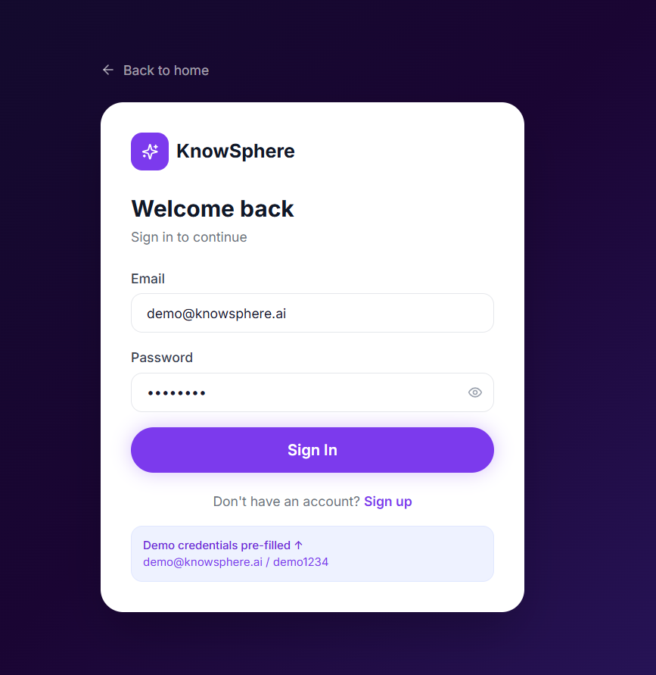

Description : The entry screen, where users sign in with an email and password (or register). On success the backend returns a bearer token that authorizes chat, upload, and profile requests.

Dashboard:

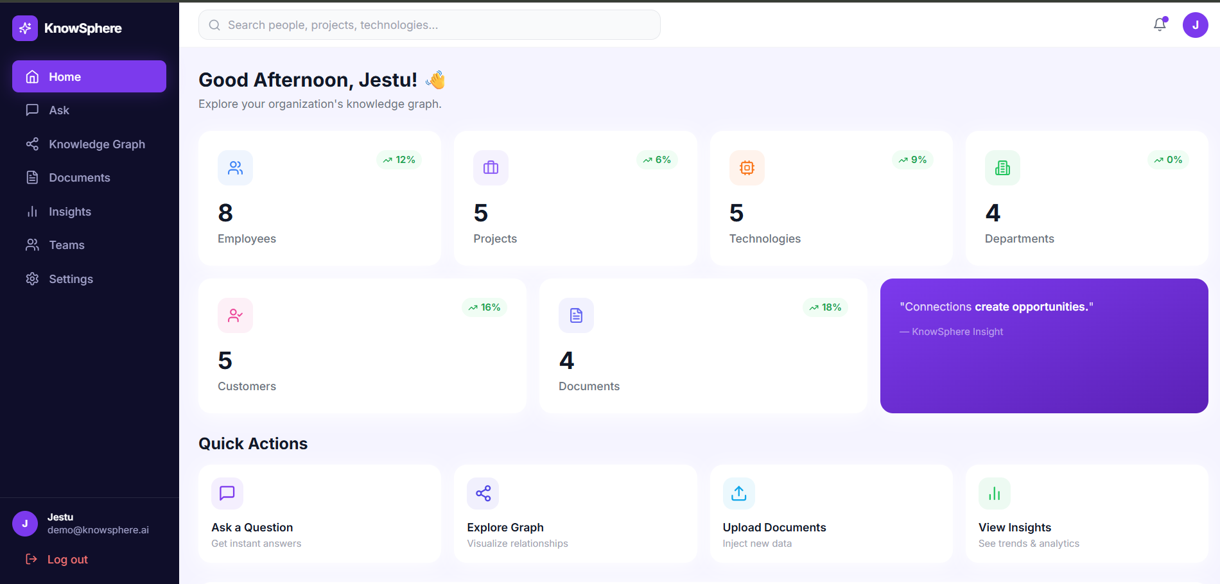

Description : An overview of the knowledge base showing live counts of employees, projects, technologies, departments, customers, teams, and documents, together with recent activity.

Ask:
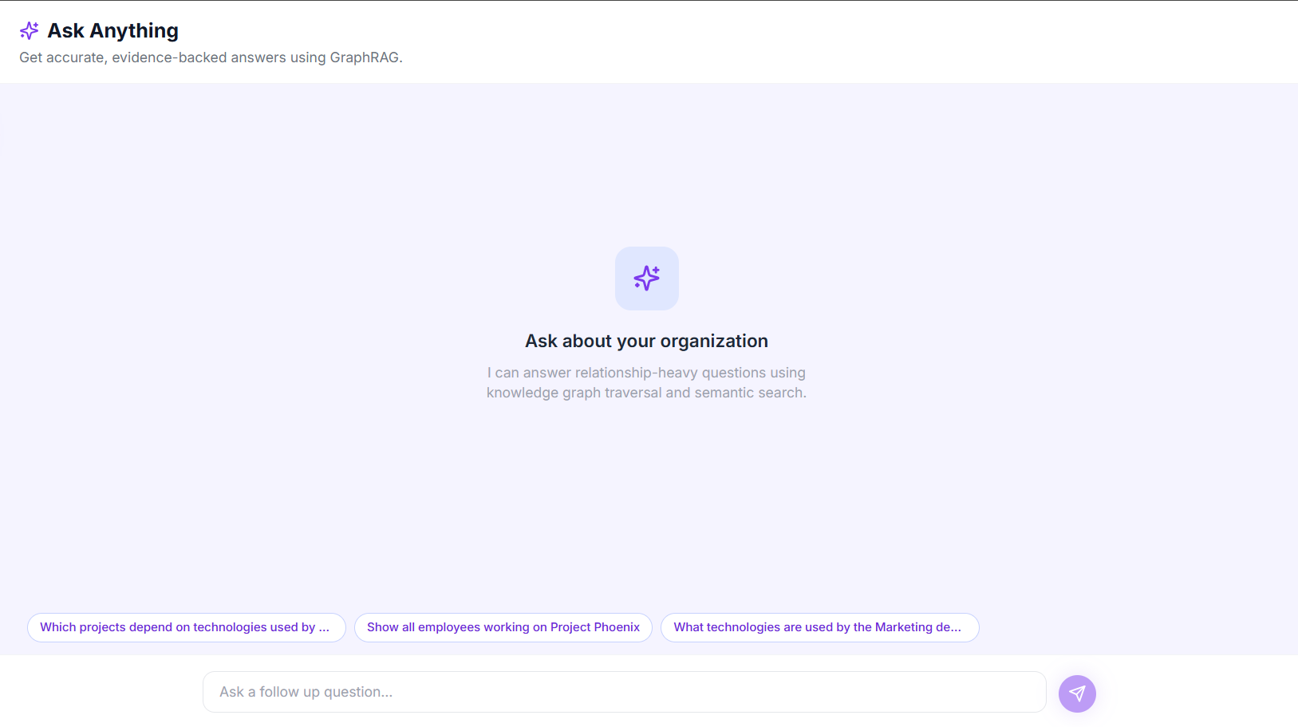
Description : The conversational GraphRAG interface. Users type a question and receive an answer with findings, a graph-path explanation, cited source documents, follow-up suggestions, and a visualized subgraph; previous sessions can be reopened from the chat history.

Graph:
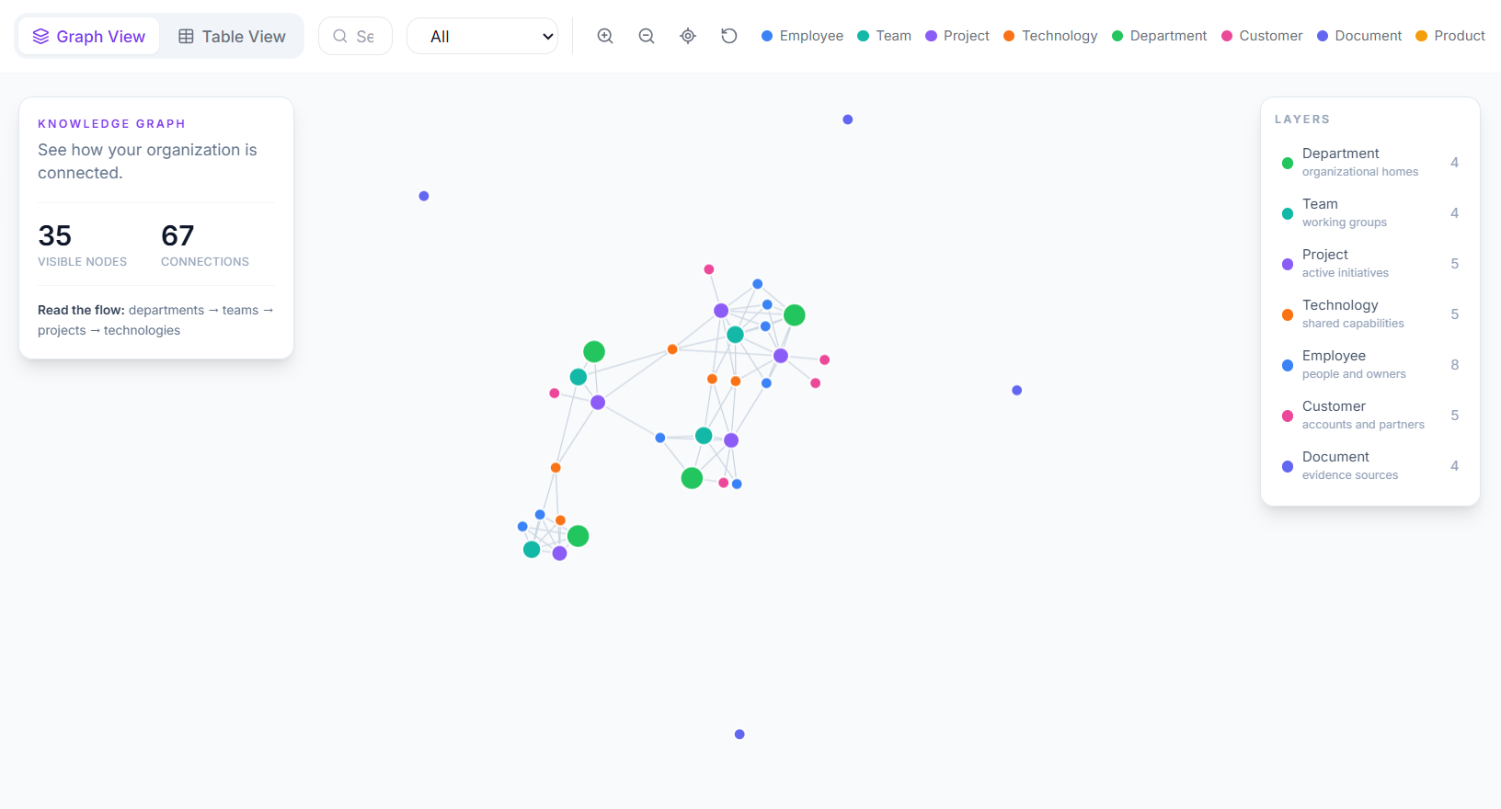
Description : An interactive network view of entities and relationships. Users can filter nodes by type, open a node's details, expand its neighbors, and find the shortest path between two nodes.

Documents:
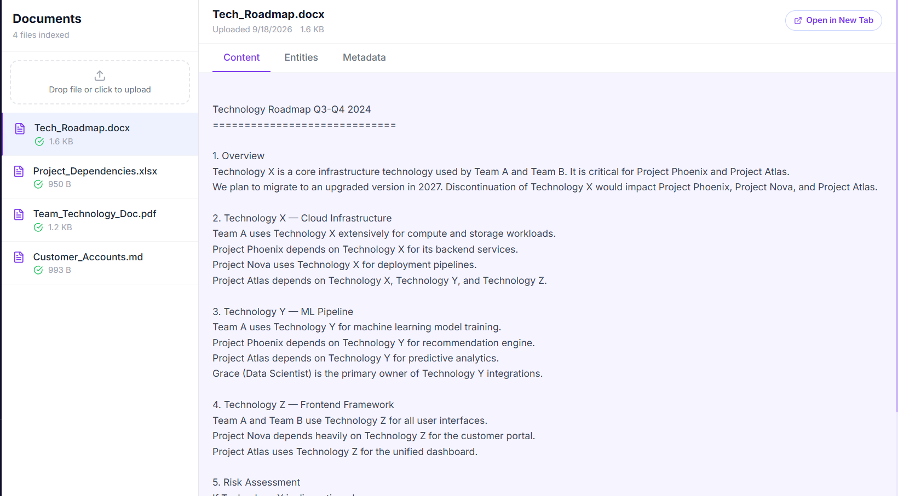
Lists uploaded documents with size, processing status, and timestamps. Users can upload supported files, then open a document to read its extracted content and the entities identified in it.

Analytics:
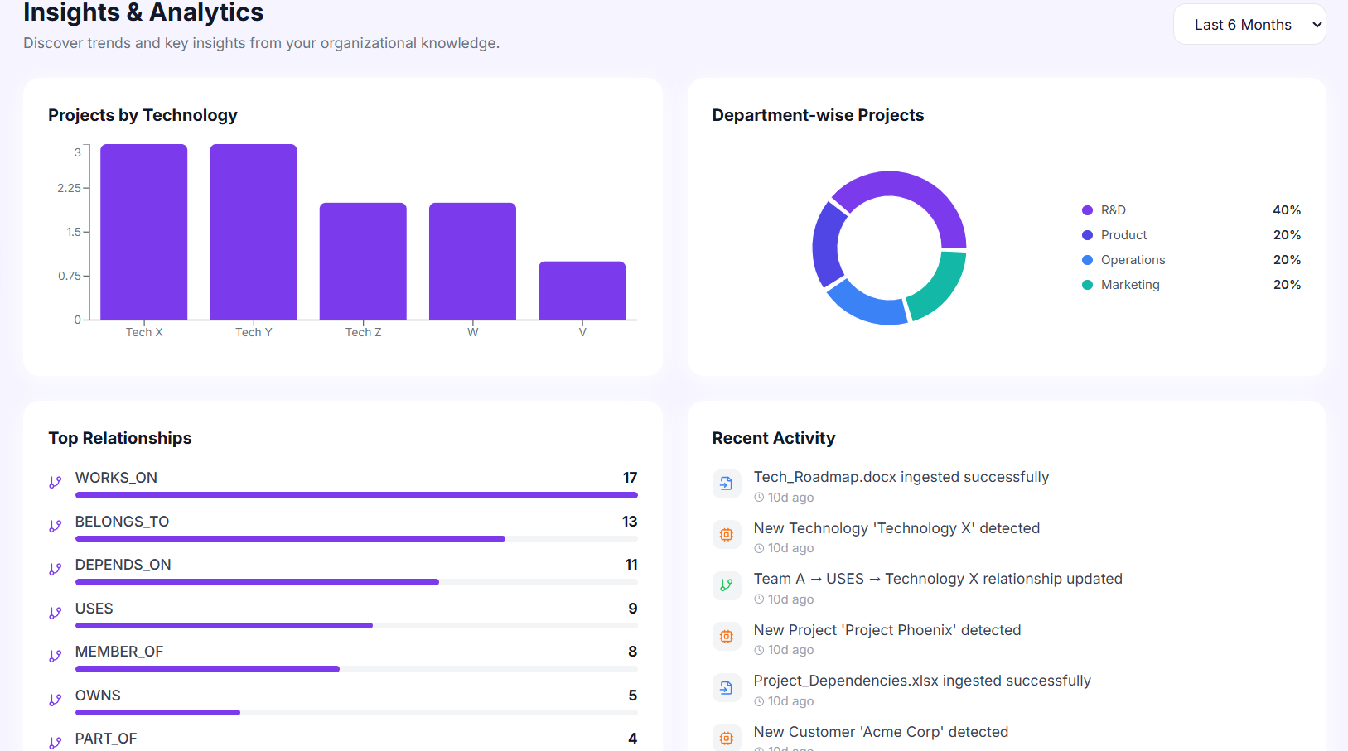
Description : Charts and tables for projects per technology, project counts per department, and the most frequent relationship types in the graph.

Settings:
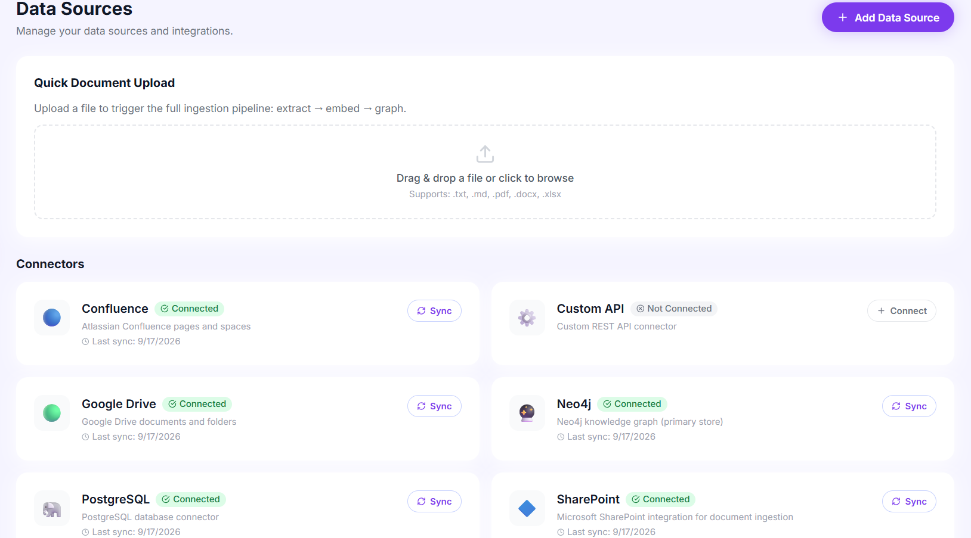

Description : The configuration page of the application. The backend also provides data-source endpoints for listing, creating, and syncing sources, where file upload is the only fully functional connector in this demo and the others are stubs that update their sync timestamp.

Conclusion:
KnowSphere is a GraphRAG corporate knowledge explorer built with FastAPI, React + TypeScript, Neo4j / NetworkX, FAISS, and Groq's openai/gpt-oss-20b. By combining dense semantic search with explicit graph traversal, it answers multi-hop questions that standard vector RAG cannot, and it keeps every answer verifiable through cited documents, confidence-oriented findings, and a visual trace of the relationships that produced it.
The project, which spanned retrieval and graph architecture design, a document-ingestion pipeline, an authenticated API, and an interactive graph-centric frontend, shows how a hybrid pipeline with a graceful embedded fallback can be run with a single command or scaled to containers. Looking ahead, KnowSphere is positioned to grow by turning the current stub data-source connectors into real integrations, tightening CORS and demo credentials for production, and extending the graph schema with additional entity types — evolving it from a strong prototype into a production-grade enterprise knowledge platform.

